Multi-Level Anomaly Detection in Financial Transactions: A Comparative Study of Machine Learning and Deep Learning Models
Quarterly Report 2: Model Implementation and Evaluation

Siddartha Bandi
College of Engineering & Mines, University of North Dakota
Grand Forks, ND, USA
siddartha.bandi@und.edu
Course: DATA 994 – Capstone Project | Instructor: Dr. Marina E. Kim

Abstract
This quarterly report presents the implementation and evaluation of five distinct models for binary fraud detection (Level 1 classification) using the Kaggle Credit Card Fraud Detection dataset. The models include three machine learning approaches (Random Forest, XGBoost, Isolation Forest) and two deep learning architectures (Autoencoder, LSTM). Following comprehensive data preprocessing including SMOTE resampling to address severe class imbalance (577:1 ratio), all models were trained and evaluated on a held-out test set reflecting real-world fraud distribution. Results demonstrate that supervised tree-based models (Random Forest AUPRC=0.8643, XGBoost AUPRC=0.8479) significantly outperform unsupervised approaches (Isolation Forest AUPRC=0.2089, Autoencoder AUPRC=0.4606). The LSTM model achieved competitive performance (AUPRC=0.8021). Level 2 multi-class risk stratification has been deferred to Quarter 3 to enable optimization on tuned baseline models.

Keywords—fraud detection, anomaly detection, machine learning, deep learning, SMOTE, class imbalance, hierarchical classification, LSTM, autoencoder, random forest, XGBoost

I. INTRODUCTION
Building upon Quarter 1's exploratory data analysis and preprocessing pipeline, this report details the implementation of five distinct model architectures for Level 1 binary classification (Normal vs. Anomalous transactions). The primary objective for Quarter 2 was to establish baseline performance across diverse model families as a foundation for subsequent risk stratification in Quarter 3.
The Kaggle Credit Card Fraud Detection dataset presents significant challenges including extreme class imbalance (0.172% fraud rate), high-dimensional PCA-transformed features (V1-V28), and temporal dependencies across transaction sequences [1]. As outlined in Quarter 1 Section 4.4, Level 2 multi-class risk tier classification will be implemented in Quarter 3 using optimized model predictions from this baseline phase.
II. DATA PREPROCESSING PIPELINE
A. Train/Test Stratification
The dataset (284,807 transactions) was split using stratified sampling to maintain fraud prevalence across both sets: 80% training (227,845 samples, 394 fraud cases) and 20% testing (56,962 samples, 98 fraud cases). Stratification ensures representative class distribution for reliable model evaluation on imbalanced data [2].
B. Feature Scaling
StandardScaler was applied exclusively to Time and Amount features, as V1-V28 components are already PCA-normalized. The scaler was fitted only on training data to prevent data leakage, then applied to both training and test sets.
C. SMOTE Resampling
Given the 577:1 imbalance ratio, SMOTE [3] was applied to the training set only. Fig. 1 illustrates the effect of SMOTE on class distribution. SMOTE increased the training set from 227,845 to 454,902 samples, achieving a balanced 50:50 distribution. The test set remained untouched to preserve real-world fraud distribution.
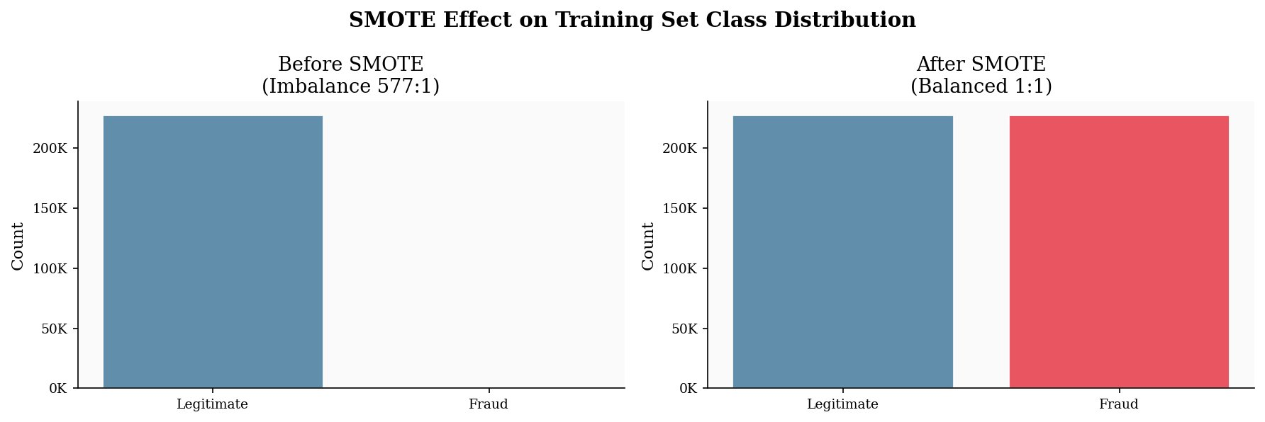
Fig. 1. SMOTE effect on training set class distribution. Left: severe imbalance (577:1) before SMOTE; right: balanced (1:1) after synthetic minority oversampling.
D. LSTM Sequence Construction
For the LSTM model, time-window sequences were constructed using a sliding window approach (window size=10, stride=1). Early transactions with insufficient history were zero-padded. This produced 454,902 training sequences and 56,962 test sequences of shape (10 timesteps, 30 features).
III. MODEL IMPLEMENTATION
A. Random Forest
Random Forest [4] served as the supervised baseline with 100 trees, maximum depth of 20, and balanced class weights. The model was trained on the SMOTE-balanced dataset in 60.82 seconds. Feature importance analysis revealed V14 (19.22%), V10 (11.28%), and V4 (10.34%) as the most discriminative features. The model achieved AUPRC of 0.8643 and AUROC of 0.9658, with 84.69% recall and 75.45% precision.
B. XGBoost
XGBoost [5] was configured with 100 estimators, maximum depth of 6, learning rate of 0.1, and scale_pos_weight calculated from the class distribution. The model achieved AUPRC of 0.8479 with AUROC of 0.9762. XGBoost demonstrated the highest recall among all models (89.80%), though with lower precision (37.55%) than Random Forest.
C. Isolation Forest
As an unsupervised approach, Isolation Forest [6] was trained on the original (imbalanced) training set with contamination parameter set to the observed fraud rate (0.1729%). The model achieved AUPRC of only 0.2089 and AUROC of 0.9543, significantly underperforming supervised methods. The poor precision-recall trade-off (33.67% recall, 30.84% precision) suggests difficulty distinguishing fraud from legitimate outliers [13].
D. Autoencoder
The Autoencoder architecture (30→16→8→16→30) was trained exclusively on legitimate transactions to learn normal patterns [7]. Using a threshold at the 95th percentile of training reconstruction errors (0.8149), the model achieved AUPRC of 0.4606 and AUROC of 0.9762. Fig. 2 shows the reconstruction error distribution and training convergence.
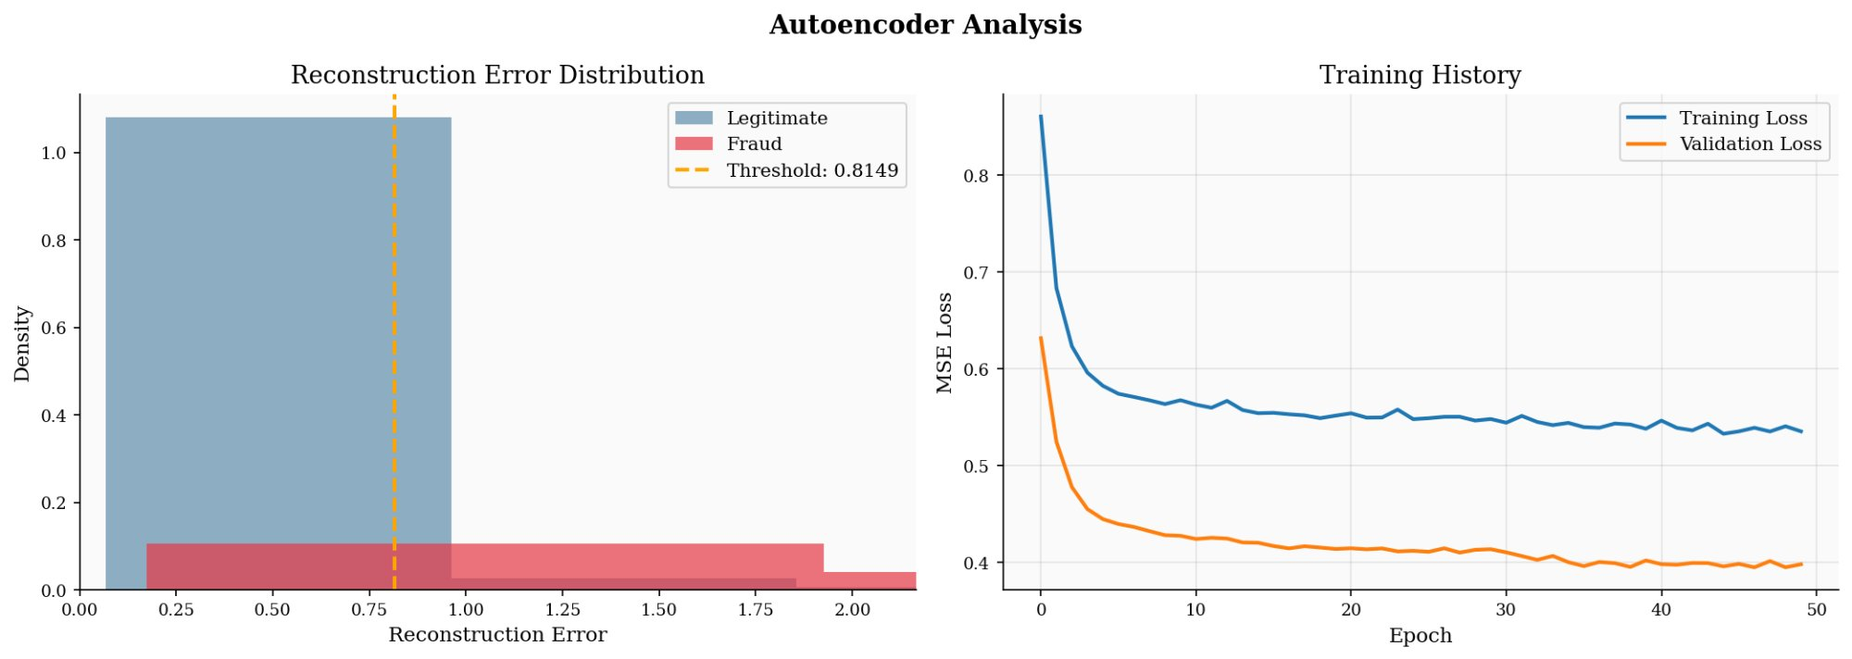
Fig. 2. Autoencoder reconstruction error analysis. Left: error distributions for fraud (red) and legitimate (blue) with decision threshold (orange). Right: training convergence showing stable validation loss.
E. LSTM
The LSTM architecture consisted of two LSTM layers (64 and 32 units) with dropout (0.3) and dense layers (16→1 with sigmoid activation). Training with early stopping completed in approximately 30 epochs. The model achieved AUPRC of 0.8021 and AUROC of 0.9762. Fig. 3 shows stable training convergence.
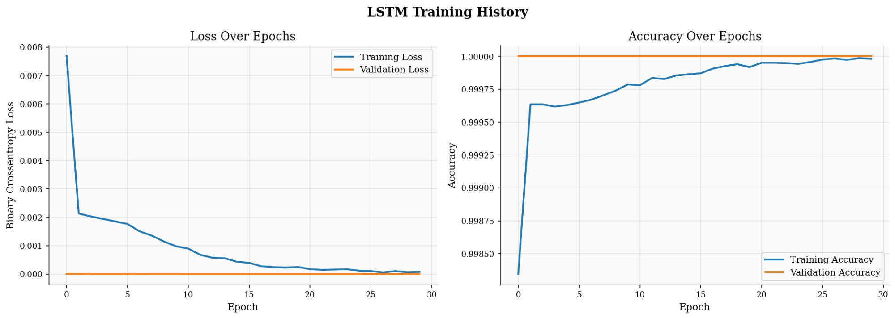
Fig. 3. LSTM training history over 30 epochs. Left: binary cross-entropy loss for training and validation. Right: accuracy convergence approaching perfect classification.
IV. COMPARATIVE RESULTS
A. Performance Metrics
Table I presents the comprehensive performance comparison across all five models evaluated on the imbalanced test set. AUPRC serves as the primary metric due to its sensitivity to class imbalance [10].
TABLE I
Comprehensive Performance Comparison Across All Five Models
Model | AUPRC | AUROC | Prec. | Recall | F1
Rand. Forest | 0.8643 | 0.9658 | 0.7545 | 0.8469 | 0.7981
XGBoost | 0.8479 | 0.9762 | 0.3755 | 0.8980 | 0.5260
Isol. Forest | 0.2089 | 0.9543 | 0.3084 | 0.3367 | 0.3220
Autoencoder | 0.4606 | 0.9762 | 0.0282 | 0.8571 | 0.0545
LSTM | 0.8021 | 0.9762 | 0.8488 | 0.7449 | 0.7935

Random Forest achieved the highest AUPRC (0.8643), establishing it as the best overall performer. XGBoost demonstrated the highest recall (89.80%), making it preferable when maximizing fraud detection rate is paramount. The LSTM achieved competitive performance (AUPRC=0.8021) with notably high precision (84.88%). Best results per column are shown in bold.
B. Precision-Recall Trade-offs
Fig. 4 presents precision-recall curves for all five models, visualizing the trade-off space. Supervised models (Random Forest, XGBoost, LSTM) maintain high precision across moderate recall ranges, while unsupervised approaches show rapid precision degradation.
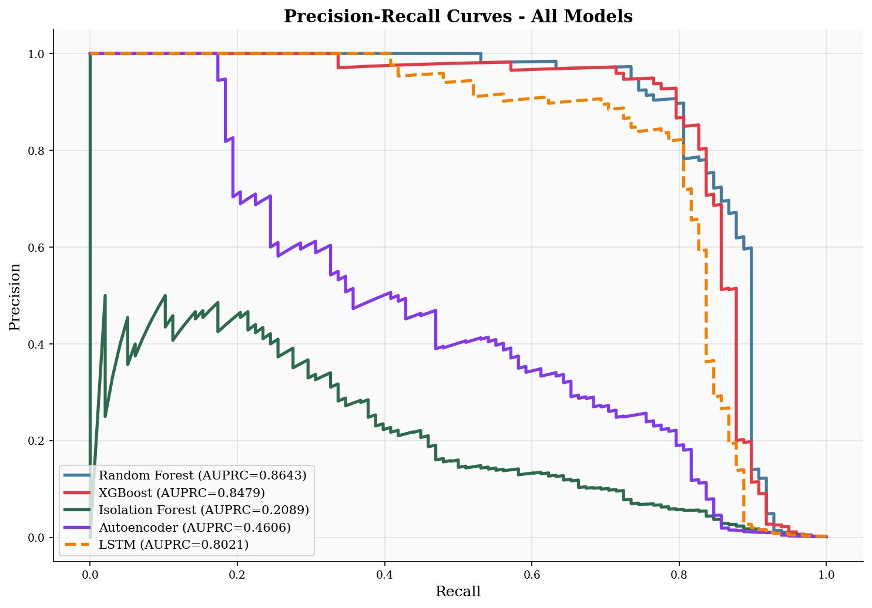
Fig. 4. Precision-recall curves for all five models. Supervised methods (Random Forest, XGBoost, LSTM) dominate the upper-right region. Unsupervised approaches (Isolation Forest, Autoencoder) show substantially lower performance.
V. DISCUSSION
A. Key Findings
Three critical insights emerged from Quarter 2 implementation. First, supervised learning dramatically outperforms unsupervised approaches when labeled data is available—the 75–313% improvement in AUPRC (Random Forest vs. Autoencoder) demonstrates that fraud labels enable models to learn nuanced patterns distinguishing malicious from merely unusual transactions.
Second, SMOTE successfully addresses class imbalance for supervised models. The balanced training set enables effective learning of fraud patterns while maintaining realistic test set evaluation. Third, temporal dependencies captured by the LSTM provide meaningful but incremental value over independent transaction classification.
B. Model Selection Considerations
For deployment, Random Forest offers the optimal balance of performance (highest AUPRC), interpretability (feature importance), and computational efficiency. XGBoost presents an attractive alternative when maximizing fraud detection rate is paramount, accepting higher false positive rates. The LSTM, despite competitive performance, requires significantly more computational resources and lacks the interpretability of tree-based methods.
Unsupervised methods proved inadequate as standalone detectors in this evaluation. However, their complementary detection patterns suggest potential value in ensemble approaches to be explored in Quarter 3.
C. Level 2 Risk Stratification: Deferral to Quarter 3
Following best practices in hierarchical classification [14], Quarter 2 focused exclusively on establishing robust Level 1 binary classification baselines. This sequential approach ensures that Level 2 risk tiers will be calibrated using optimized model predictions rather than preliminary baseline outputs. Quarter 3 will implement the tercile-based threshold scheme described in Quarter 1, stratifying fraud predictions into Low, Medium, and High risk tiers.
D. Limitations
Several limitations warrant acknowledgment: (1) the dataset's PCA transformation prevents direct interpretation of raw transaction features; (2) SMOTE generates synthetic samples that may not perfectly represent real fraud patterns; (3) baseline hyperparameters were used for all models; and (4) evaluation on a single dataset limits generalizability.
VI. QUARTER 3 PLAN
Quarter 3 will focus on four primary objectives. First, systematic hyperparameter optimization for all five models using grid search or Bayesian optimization to maximize AUPRC. Second, implementation of Level 2 multi-class risk stratification (Low/Medium/High) by engineering risk labels from optimized prediction probabilities. Third, comprehensive cost-benefit analysis incorporating realistic fraud costs. Fourth, evaluation of ensemble methods combining complementary models.
The final deliverable will include Quarterly Report 3, a comprehensive final paper documenting the complete hierarchical framework with both Level 1 binary and Level 2 multi-class performance, and a recorded presentation synthesizing all three quarters of work.
VII. CONCLUSION
Quarter 2 successfully implemented and evaluated five diverse models for credit card fraud detection, establishing strong baseline performance for Level 1 binary classification. Random Forest emerged as the top performer (AUPRC=0.8643) among baseline configurations, with XGBoost offering a high-recall alternative (89.80% recall) and LSTM demonstrating competitive performance leveraging temporal patterns. The substantial performance gap between supervised and unsupervised approaches validates the value of labeled training data. Level 2 multi-class risk stratification has been appropriately deferred to Quarter 3 to enable calibration on optimized model predictions.
REFERENCES
[1] A. Dal Pozzolo, O. Caelen, R. A. Johnson, and G. Bontempi, “Calibrating probability with undersampling for unbalanced classification,” in Proc. IEEE Symp. Comput. Intell. Data Mining (CIDM), Cape Town, South Africa, 2015, pp. 159–166.
[2] E. W. T. Ngai, Y. Hu, Y. H. Wong, Y. Chen, and X. Sun, “The application of data mining techniques in financial fraud detection: A classification framework,” Decis. Support Syst., vol. 50, no. 3, pp. 559–569, 2011.
[3] N. V. Chawla, K. W. Bowyer, L. O. Hall, and W. P. Kegelmeyer, “SMOTE: Synthetic minority over-sampling technique,” J. Artif. Intell. Res., vol. 16, pp. 321–357, 2002.
[4] L. Breiman, “Random forests,” Mach. Learn., vol. 45, no. 1, pp. 5–32, 2001.
[5] T. Chen and C. Guestrin, “XGBoost: A scalable tree boosting system,” in Proc. 22nd ACM SIGKDD Int. Conf. Knowl. Discovery Data Mining, San Francisco, CA, 2016, pp. 785–794.
[6] F. T. Liu, K. M. Ting, and Z.-H. Zhou, “Isolation forest,” in Proc. 8th IEEE Int. Conf. Data Mining (ICDM), Pisa, Italy, 2008, pp. 413–422.
[7] M. Sakurada and T. Yairi, “Anomaly detection using autoencoders with nonlinear dimensionality reduction,” in Proc. MLSDA 2014 2nd Workshop Mach. Learn. Sensory Data Anal., Gold Coast, Australia, 2014, pp. 4–11.
[8] S. Hochreiter and J. Schmidhuber, “Long short-term memory,” Neural Comput., vol. 9, no. 8, pp. 1735–1780, 1997.
[9] H. He, Y. Bai, E. A. Garcia, and S. Li, “ADASYN: Adaptive synthetic sampling approach for imbalanced learning,” in Proc. IEEE Int. Joint Conf. Neural Netw., Hong Kong, 2008, pp. 1322–1328.
[10] J. Davis and M. Goadrich, “The relationship between Precision-Recall and ROC curves,” in Proc. 23rd Int. Conf. Mach. Learn., Pittsburgh, PA, 2006, pp. 233–240.
[11] J. Jurgovsky et al., “Sequence classification for credit-card fraud detection,” Expert Syst. Appl., vol. 100, pp. 234–245, 2018.
[12] V. Van Vlasselaer et al., “APATE: A novel approach for automated credit card transaction fraud detection using network-based extensions,” Decis. Support Syst., vol. 75, pp. 38–48, 2015.
[13] X. Zhang, Y. Han, W. Xu, and Q. Wang, “HOBA: A novel feature engineering methodology for credit card fraud detection with a deep learning architecture,” Inf. Sci., vol. 557, pp. 302–316, 2021.
[14] C. N. Silla and A. A. Freitas, “A survey of hierarchical classification across different application domains,” Data Min. Knowl. Discov., vol. 22, no. 1-2, pp. 31–72, 2011.

